SIMATS ENGINEERING (SAVEETHA SCHOOL OF ENGINEERING)
Department of Computer Science and Engineering

ASSESSMENT TOOL 3 – Comparative Analysis

Course Code: | CSA0612 | Course Title: | Design and Analysis of Algorithms
CO Assessed: | CO4: Articulation (BL4, BL5) | Assessment: | Assessment Tool 3 – Comparative Analysis
Weightage: | 10% of CIA | Total Marks: | 100
CO4 Statement: | Solve optimization problems using dynamic programming and greedy strategies.
Student Name: | DIVYASREE.P | Reg. No.: | 192565016
Section / Batch: | 2025 | Date: | 25/08/2026
Instructions to Students

- Answer the following question. Total Marks: 100.
- Analyze the given questions thoroughly before answering.
- Compare multiple aspects such as methods, results, advantages, and limitations clearly.
- Critically evaluate the strengths, weaknesses, and implications with proper justification.
- Present meaningful insights, interpretations, and well-supported conclusions from the comparisons.

Question Type | Focus Area | Questions
Comparative Analysis | Comparative analysis of Dynamic Programming and Greedy algorithms for optimization problems. | Q1

SECTION A – Comparative Analysis

Code of Conduct
I DIVYASREE.P(192565016) (Name / Reg No) certify that this submission is my original work and that I have adhered to the guidelines specified for this assessment. I understand that any violation of academic integrity rules will result in disciplinary action.
Signature of the Student:

RUBRICS FOR CALCULATION

Comparative Analysis
Criteria | Weightage | Level 4 (Exemplary) | Level 3 (Proficient) | Level 2 (Developing) | Level 1 (Beginning)
Selection of Studies/Parameters | 20% | Selects highly relevant and diverse studies with well-defined comparison parameters | Selects relevant studies with minor gaps in parameter definition | Limited or partially relevant selection | Poor or inappropriate selection of studies
Comparison & Differentiation | 25% | Clearly compares multiple aspects (methods, results, limitations) with strong  differentiation | Good comparison with minor gaps | Basic comparison  with limited depth | No clear comparison;  mostly descriptive
Critical Evaluation | 25% | Critically evaluates strengths, weaknesses, and implications with  strong justification | Provides evaluation with  some justification | Limited evaluation;  lacks depth | No critical evaluation  provided
Synthesis & Insight Generation | 20% | Generates meaningful insights and conclusions  from comparisons | Some insights derived from  comparison | Limited or unclear insights | No insights generated
Clarity | 10% | Information is clearly presented (tables/figures) with  logical structure | Generally clear with minor issues | Presentation lacks clarity or  structure | Poor presentation and difficult to  understand

Marks Evaluation:
Criteria | Wt. | Level 4 – Exemplary | Level 3 – Proficient | Level 2 – Developing | Level 1 – Beginning
Selection of Studies/Parameters | 20%
Comparison & Differentiation | 25%
Critical Evaluation | 25%
Synthesis & Insight Generation | 20%
Clarity | 10%
Total Marks (100):

Faculty In-charge | Course Coordinator | Head of Department
Name: | Name: | Name:
Signature: | Signature: | Signature:
Date: | Date: | Date:

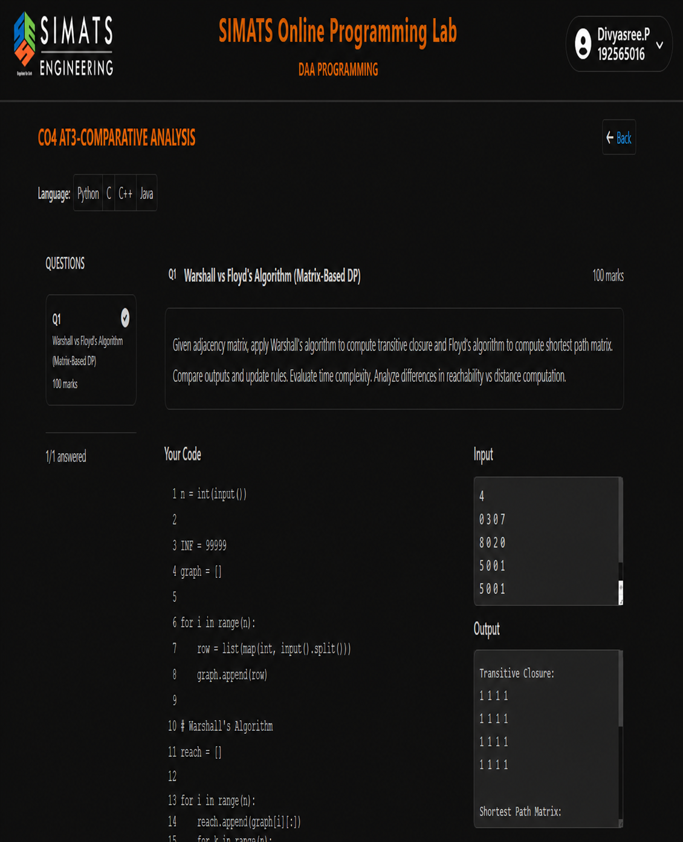

Short Question Report

Title: Warshall vs Floyd’s Algorithm (Matrix-Based DP)

Objective:
To apply Warshall’s algorithm for finding transitive closure and Floyd’s algorithm for finding the shortest-path matrix from a given adjacency matrix.

Algorithms:
- Warshall’s Algorithm: Determines whether a path exists between every pair of vertices.
- Floyd’s Algorithm: Calculates the shortest distance between every pair of vertices.

Input:
An adjacency matrix representing the graph.

Comparison:
Warshall | Floyd
Finds reachability | Finds shortest distances
Output: 0/1 matrix | Output: distance matrix
Uses Boolean operations | Uses minimum-distance operations

Time Complexity:
Both algorithms take O(n³) time.

Space Complexity:
O(n²) for storing the matrices.

Conclusion:
Warshall’s algorithm is suitable for reachability/transitive closure, while Floyd’s algorithm is suitable for all-pairs shortest-path computation. Both use a matrix-based dynamic programming approach.
IN TWO PAGES ONLY

QUESTION REPORT

Warshall vs Floyd’s Algorithm (Matrix-Based Dynamic Programming)

1. Introduction

Warshall’s and Floyd’s algorithms are important dynamic programming techniques used for graph problems. Both algorithms work on a matrix representation of a graph and use three nested loops to update the matrix. However, their objectives are different.
Warshall’s algorithm is used to calculate the transitive closure of a graph, which determines whether one vertex is reachable from another. Floyd’s algorithm, also known as the Floyd-Warshall shortest-path algorithm, is used to calculate the shortest distance between every pair of vertices.
The given problem provides an adjacency matrix and requires both algorithms to be applied and their results compared.

2. Objective

The main objectives of this question are:
- To implement Warshall’s algorithm.
- To find the transitive closure of a graph.
- To implement Floyd’s shortest-path algorithm.
- To calculate the shortest path between every pair of vertices.
- To compare the outputs and update rules of both algorithms.
- To analyze their time and space complexity.

3. Input Representation

The graph is represented using an adjacency matrix.
For the given example, the input begins with:
4
0 3 0 7
8 0 2 0
5 0 0 1
2 0 0 1
Here, 4 represents the number of vertices. The remaining values represent connections and their weights.
A value of 0 may indicate that there is no direct connection, depending on the representation used by the program.
4. Warshall’s Algorithm

Warshall’s algorithm determines reachability between every pair of vertices.
It answers the question:
“Can vertex i reach vertex j?”
The algorithm maintains a Boolean matrix called the reachability matrix.
The basic update rule is:
Reach[i][j]=Reach[i][j] OR (Reach[i][k] AND Reach[k][j])Reach[i][j] = Reach[i][j] \ OR\ (Reach[i][k] \ AND\ Reach[k][j])
For every intermediate vertex k, the algorithm checks whether a path from i to j can be formed through k.

Result

The output is a transitive closure matrix, containing 1 when a vertex is reachable and 0 otherwise.
In the screenshot, the transitive closure is:
1 1 1 1
1 1 1 1
1 1 1 1
1 1 1 1
This indicates that all vertices are reachable from one another in the given graph.

5. Floyd’s Algorithm

Floyd’s algorithm calculates the shortest path between every pair of vertices.
Instead of simply checking whether a path exists, it calculates the minimum possible distance.
The update rule is:
D[i][j]=min⁡(D[i][j],D[i][k]+D[k][j])D[i][j] = \min(D[i][j], D[i][k] + D[k][j])
Here:
- D[i][j] = current shortest distance from i to j
- D[i][k] = distance from i to k
- D[k][j] = distance from k to j
If travelling through vertex k gives a shorter route, the matrix is updated.
The final matrix therefore contains the shortest distances between all pairs of vertices.

6. Comparison of Warshall and Floyd Algorithms
Feature | Warshall’s Algorithm | Floyd’s Algorithm
Main purpose | Transitive closure | Shortest paths
Determines | Reachability | Minimum distance
Matrix type | Boolean matrix | Distance matrix
Main operation | OR / AND | MIN / addition
Output | 0 or 1 | Shortest distances
Technique | Dynamic Programming | Dynamic Programming
Time Complexity | O(n³) | O(n³)
Space Complexity | O(n²) | O(n²)
Both algorithms have the same asymptotic complexity, but they solve different graph problems.

7. Dynamic Programming Approach

Both algorithms follow the dynamic programming principle of gradually considering vertices as possible intermediate points.
Initially, the matrix contains direct connections. Then vertex 0 is considered as an intermediate vertex, followed by vertex 1, vertex 2, and so on.
For Warshall, the matrix is updated using logical operations:

8. Complexity Analysis

Both algorithms use three nested loops over the number of vertices.
Therefore, their time complexity is:
O(n3)\boxed{O(n^3)}
If the graph contains n vertices, approximately n3n^3 matrix operations may be performed.
The matrices require:
O(n2)\boxed{O(n^2)}
space.
This makes both algorithms suitable for small and medium-sized graphs. For very large graphs, other graph algorithms may be more efficient depending on the problem.

9. Applications

Warshall’s Algorithm
Warshall’s algorithm can be used in:
- Network connectivity analysis
- Route availability
- Dependency analysis
- Social network reachability
- Finding connected relationships

Floyd’s Algorithm
Floyd’s algorithm can be used in:
- Road and transportation networks
- Computer networks
- Routing systems
- Flight route optimization
- Finding shortest paths between locations

10. Conclusion

Warshall’s and Floyd’s algorithms are matrix-based dynamic programming algorithms with similar structures but different purposes.

Warshall’s algorithm focuses on reachability, producing a transitive closure matrix that indicates whether a path exists between two vertices. Floyd’s algorithm focuses on distance, producing a shortest-path matrix containing the minimum distance between every pair of vertices.

